1. **Introduction**

We know about the increasing use of social networking sites, people use various social media platforms depending on their requirements and interest. Social media is a dynamic platform that can be used in so many ways to share news, knowledge, entertainment etc. In this project, like social media platform, we are going to develop a Travel Feed for destination’s in Nepal especially for Kathmandu Valley. Everyone associated with the traveling like bloggers, digital nomads, solo travelers or a family can share their experience of that destination to the rest of the world through our platform. Other users can get influence to travel, get connected to other travelers, know information about destination. Our system mainly focuses on giving recommendation about destination for a particular user. It does so by dividing our user base to a group of clustering, providing a genuine rating about destination profile. The recommendation will also depend on the user activities and analysis of engagement about corresponding destination shared by experienced users. User will able to follow other users and destinations, and can view corresponding profile.

**2. Problem Statement**

Nowadays, when people decide to do travel, they start searching information in internet. They want get different kind of information of particular destination before going there. Unmanaged information in the internet really bother travelers to extract useful information about different places. Not only the information, some people want to explore new destination to travel. All information about any destination can’t be found in one particular place. So people need to spend a lot of time to gather useful information.

Few major problems out there are;

* Unmanaged information of travel destination.
* Difficulties in exploring new travel destination.
* Variation in information about the same travel destination.
* Too much time required to get valuable information.

1. **Objectives**

The main objective of this project is to increase the tourism activity by providing the

concise content of the destination according to user interest.

Few major objectives are;

* To recommend travel destination inside valley.
* To create profile of travel destinations to reduce variation in information.
* To connect fellow travelers.
* To promote unnoticed destinations.

1. **Scope and Limitations**

This platform is better for every people who loves to travel, explore new destinations. This platform helps to get connected with like-minded travelers and gives power to share their travel experience to the platform. Users can get to know about unnoticed destinations across the Kathmandu valley, and thereby it helps to grow travel ecosystem of Nepal.

Some limitations are;

* Admin need to approve newly created destination profile, system can’t do.
* Other users can’t have access to edit destination profile content.

1. **Research Methodology**
   1. **Literature Review**

Over the years, tourism has continued to gain massive interest at a global scale. It is a major foreign exchange earner for a good number of advanced and emerging economies. It is also true that information explosion makes it cumbersome times to access relevant information to enhance decision making. This has given rise to the emergence of intelligent systems or mechanisms that facilitate quick access to relevant content found in the Internet [1].

The new TripAdvisor expands its community beyond travelers to also include brands, social media influencers, publishers and friends. Travelers can follow and connect with individuals or content creators who share information that is relevant to their interests. Complementing our more than 661 million reviews and opinions, TripAdvisor members will be able to create and view inspirational and helpful new forms of content including photos, videos and articles. Members will also have the ability to create "Trips," which can be in-depth travel guides, itineraries or simple wish lists of things to do while traveling. Trips can be made private and saved for personal use or shared with the community to inspire and help others. Powered by the world's first "travel feed," TripAdvisor members will be able to discover more relevant information faster when planning travel. Assisted throughout the entire travel planning process, members can draw advice and inspiration from their friends, family and trusted experts [2].

In this era that has witnessed rapid advances in information technology, information overload has become a serious problem to those seeking for information online. Recently, intelligent search mechanisms have been deployed on the web that shows that the problem of information overload can be partially eliminated by providing a platform with more intelligence to assist tourists in the search for relevant information [3].

Google.com is an example of an intelligent search engine that helps users with information and another class of intelligent system that has proven relevant in addressing the problem of information overload are recommender systems [4].

Recommender systems are commonly defined as applications that e-commerce sites exploit to suggest products and provide consumers with information to facilitate their decision-making processes. They implicitly assume that we can map user needs and constraints, through appropriate recommendation algorithms, and convert them into product selections using knowledge compiled into the intelligent recommender. Knowledge is extracted from either domain experts (content- or knowledge-based approaches) or extensive logs of previous purchases (collaborative-based approaches). Furthermore, the interaction process, which turns needs into products, is presented to the user with a rationale that depends on the underlying recommendation technology and algorithms [5].

The k-means algorithm is the most popular clustering tool used in scientific and industrial applications. The k-means algorithm is best suited for data mining because of its efficiency in processing large data sets. Clustering is one of the well-known Data mining techniques to find useful pattern from a data in a large database. However, working only on numeric values limits its use in data mining because data sets in data mining often have categorical values. The k-means algorithm takes the input parameter, k (Clusters), and partitions a set of n objects into k clusters so that the resulting intra cluster similarity is high but the inter cluster similarity is low. Cluster similarity is measured in regard to the mean value of the objects in a cluster, which can be viewed as the cluster’s centroid or center of gravity. The biggest advantage of the k-means algorithm in datamining applications is its efficiency in clustering large data sets. Data mining adds to clustering the complications of very large datasets with very many attributes of different types.

The process of grouping a set of physical or abstract objects into classes of similar objects is called clustering. A cluster is a collection of data objects that are similar to one another within the same cluster and are dissimilar to the objects in other clusters. A cluster of data objects can be treated collectively as one group. Although classification is an effective means for distinguishing groups or classes of objects, it requires often costly collection and labeling of a large set of training tuples or patterns, which the classifier uses to model each group. Clustering is also called data segmentation in some applications because clustering partitions large data sets into groups according to their similarity [6].

In the aspect of tourism, Internet and web technologies have made more readily available information on tourist locations, accommodations, transportation, shopping, food, festivals, and other attractions, thus improving travel experience [7].

* 1. **Data Collection**

The data for this project will be collected as a crowdsourcing mechanism from user. Some data about certain places will added by researching their content by visiting fields, Wikipedia and many more.

* 1. **Feasibility Study**

Feasibility Analysis is an assessment of the practicality of a proposed project. It provides the degree of viability of a proposed project. A feasibility analysis helps us determine the value of the proposed project, determine whether or not there is a market for the proposed project, determine if the proposed project is financially viable, and eventually, decide whether or not it is worth investing time and money into the proposed project.

In short, a feasibility analysis evaluates the project’s potential for success. Following Feasibility Analysis is performed prior to working on the project.

* + 1. **Technical feasibility**

This is a web-based application. It uses HTML, CSS, and JavaScript as front end and PHP as a back end. It is based on client server architecture and needs internet connection to access the information. All the technology required by the application are available and can be accessed freely, hence it is technically feasible.

* + 1. **Operational feasibility**

The end users are the client of the application. They are the one who add and search for the various information. The server keeps the records of various information and users. The application can be accessed from anywhere with an internet connection. It is easy to use. Thus, it was determined to be operationally feasible.

* + 1. **Economic Feasibility**

For development, PCs that support any Operating System with some applications is sufficient. For deployment, a PC with internet is required. During data collection too, not much cost was spent and same with time as well. Further, it does not cost much to develop and access this system and hence, we can say it is economically feasible to develop the system.

* + 1. **Schedule Feasibility**

A system is said to be scheduled feasible if it is implemented within the planned scheduled. We carried out the study on how much it will take to complete the task after studying the requirements and proposed plan. So, as per the analysis it has to be feasible to carry out the project with respect to the available time.

* 1. **Analysis and Design:**

**5.4.1. ER (Entity-Relation) Diagram:**

The system contains the following entity sets and relationship sets along with their descriptions:

* **User**

They are the clients who use our system they can share posts, create destination, and engage with content.

* **Post**

It is created by user for users.

* **Destination**

It is the profile created by users which include information about that place.

* **Reacts**

This is the engagement functionality for users to do like, dislike and comments.

* **Follows**

This is a kind of action to get access to contents of other users.

The ER diagram of our proposed work is given as below:

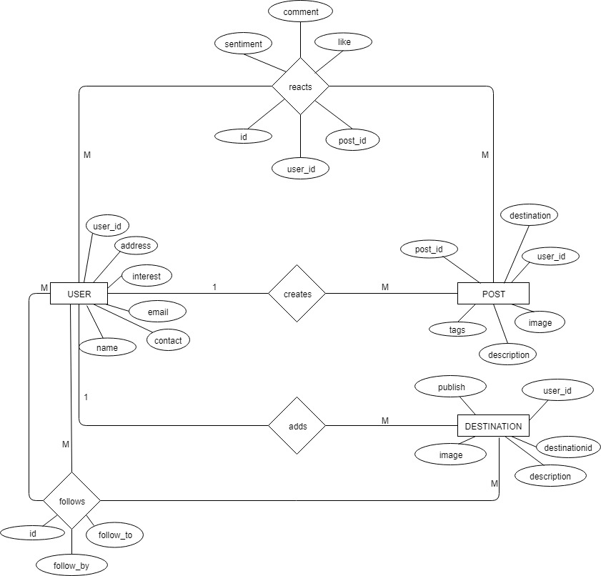

*Fig 1: ER Diagram of proposed system*

**5.4.2. Data Flow Diagram**

A data-flow diagram (DFD) represents a flow of our data of a process or a system. The DFD also provides information about the outputs and inputs of each entity and the process itself. A data-flow diagram has no control flow, there are no decision rules and no loops.

**DFD Level – 0**

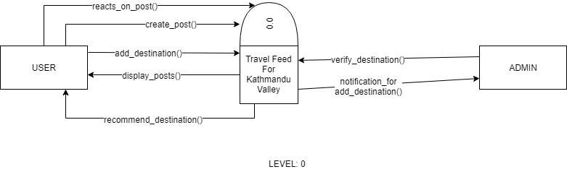

*Fig 2: DFD Level-0*

**DFD Level – 1**

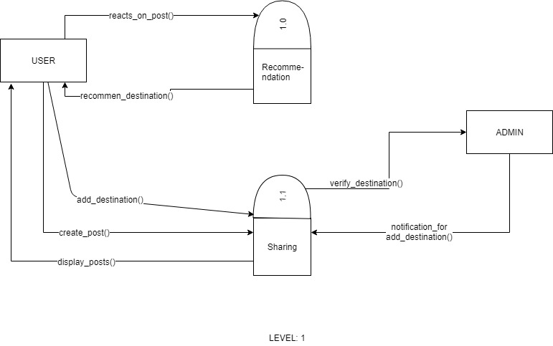

*Fig 3: DFD Level-1*

**5.4.3. Use case diagram**

There are two actors (User and Admin) who performs certain activities in our system as shown in the diagram below:

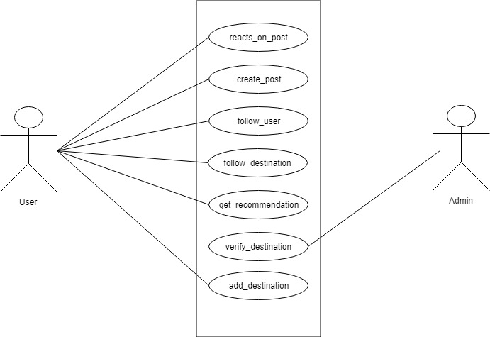

*Fig 4: Use case diagram of proposed system*

* 1. **Proposed System**

In the proposed system, user can register and create their account. During registration they can select their interest and choices. According to chosen user interest the system will recommend the user best fit travel destination inside valley. The user can manage their own profile and can add relevant information about travel destination.

The proposed system is an interactive news feed, in which user can follow another user as well as the travel destination. It uses K-means clustering algorithm to recommend the destination according to the user interest.

The Block Diagram of the system is as follows:

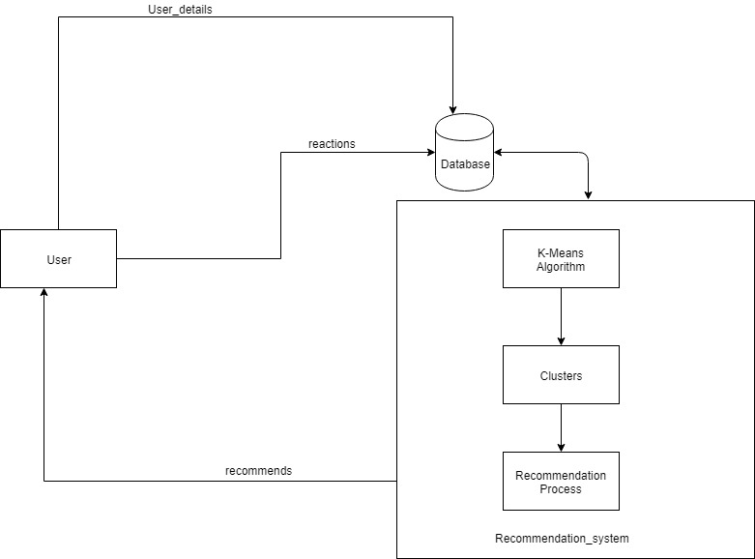

*Fig 5: Block Diagram of the proposed system*

**Algorithm Implementation**

**K-Means Clustering Algorithm**

We use K-Means to make a cluster of similar user group and do a recommendation of their similar interest for every user. It assigns data points to a cluster such that the sum of the squared distance between the data points and the cluster’s centroid (arithmetic mean of all the data points that belong to that cluster) is at the minimum. The less variation we have within clusters the more homogeneous (similar) the data points are within the same cluster.

The Euclidean distance formula is used to carry out the calculation of the centroids, which

is given by;

$$ⅆ\left(x,y\right)=\sqrt{{\left(x_{1}-y_{1}\right)}^{2}+{\left(x_{2}-y_{2}\right)}^{2}+…+{\left(x_{n}-y_{n}\right)}^{2}}$$

Where,

d(x,y) is the distance between the data point and centroid,

(x1,x2,….xn) is the data points,

(y1,y2,…..yn) is the centroids,

n is the no of data points which is same as the no of clusters (K).

The algorithm is composed of the following steps:

1. Place K points into the space represented by the objects that are being clustered. These points represent initial group centroids.
2. Assign each object to the group that has the closest centroid.
3. When all objects have been assigned, recalculate the positions of the K centroids.
4. Repeat Steps 2 and 3 until the centroids no longer move. This produces a separation of the objects into groups from which the metric to be minimized can be calculated.
   1. **Implementation Tools**

The implementation phase of the software development refers to the final process of moving the solution from development status to production status. In this phase, we will begin building and coding the software. It is also the phase where we are actually building the system. Firstly, the whole information that we gathered are studied, analyzed and then it was processed to build an actual system.

Different tools and technologies that we have used are given below.

**5.6.1. HTML, CSS, JavaScript**

As we are building a website to fulfil our purpose so obviously we had used HTML to design the layout of the system, similarly CSS is used to design the webpages to make the system more user-friendly and attractive and JavaScript is used to include the programming approach to make the design and layout more stable and accurate. These all tools are marked as the frontend of the system.

**5.6.2. Laravel**

PHP is used to handle the backend of our system, every task and function in the system are programmed with PHP framework called Laravel. It makes flexible and easy to implement K-means algorithm.

1. **Working Schedule**

For the completion of the project we will follow the time schedule given below.

*Table 1: working schedule*

**REFERENCES**

[1] Abdulhamid S.M. & Gana U. (2010). *Destination Information Management System For Tourist: Computer Science and Telecommunications.* Georgian Electronic scientific journal.

[2] TripAdvisor, “The New TripAdvisor Goes Social Gets Personal”, September 17, 2018. [Online].

Available:<http://ir.tripadvisor.com/news-releases/news-release-details/new-tripadvisor-goes-social-gets-personal>. [Accessed: Mar. 21, 2019].

[3] Anastasia A., Panagiota D. & Georgios M. (2012). *A Web-based Prototype System For Personalized Tourism Destination Discovery And Management.* Technological Educational Institute of Athens, Athens.

[4] Daramola, J. O. (2009). *A Software Product Line Approach To Ontology-Based Recommendations In E-Tourism Systems.* School Project, Convenant University, Computer And Information Science.

[5] Semantic Scholar, “Intelligent System for Tourism”. [Online].

Available:<https://pdfs.semanticscholar.org/ef8d/1bcc526d7ed8e20d276dc6379274cd94a0a9.pdf?_ga=2.130720524.266567961.1553785132-2011643095.1553785132>.

[Accessed: March. 12, 2019].

[6] Huda Hamdan Ali , Lubna Emad Kadhum, “K- Means Clustering Algorithm Applications in Data Mining and Pattern Recognition,” *International Journal of Science and Research(IJSR),* ISSN [Online].

Available:<https://medium.com/@martinpella/naive-bayes-for-sentiment-analysis-49b37db18bf8>. [Accessed: Mar. 21, 2019].

[7] Heum P., Aesun Y. & Hyuk-Chul K. (2012). *Task Model and Task Ontology for Intelligent Tourist Information Service.* International Journal of u- and e- Service, Science and Technology.